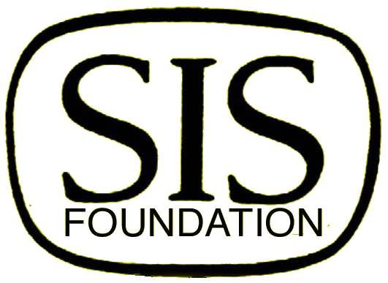
SURGICAL INFECTION SOCIETY
FOUNDATION FOR EDUCATION AND RESEARCH

St. Louis Cardinals vs. Milwaukee Brewers Game
Wednesday May 3, 2017 at 7:15pm

Enjoy a night of baseball at Busch Stadium in a Luxury Box!
Includes Food and an Open Bar!

Space is Limited - $100.00

____Visa ____MasterCard Credit Card Number: _____________________________

Exp.Date: ______ CSC: ______

Name _____________

Address _____________

City ___ State Zip _______________

Email ___________________

Number of Attendees: ____

____Check: Made payable to The Surgical Infection Society

SIS Foundation
PO Box 1278
East Northport, NY 11731
Ph: 631-368-1880
Fax: 631-368-4466

